SLRA pledges to contribute towards restoring the country’s Economy
The Sri Lanka Retail Association (SLRA) strongly condemn the Easter Sunday attacks that took place across the country which took the lives of many innocent people, injured hundreds more, causing substantial damage to the economy of the country.
“We are indeed shocked and deeply saddened by the multiple attacks that shook the entire country and disabled the Lankan economy” stated Mr. Sidath Kodikara, President of SLRA. “As an Association that comprises of members operating across the country, on behalf of all its members, SLRA pledges to extend its commitment and assistance to the Government and Security forces, enabling them to restore the country and economy to normalcy”.
SLRA was formally established with the intention being the apex body for organized retailing in the country with an ambitious vision of achieving ‘Retail Excellence’ by being the ‘voice of the Retail industry in Sri Lanka’ and inclusive in its Approach. Currently, the Association represents over 42 leading corporates including members from diverse retail sectors such as FMCG, Clothing, Fashion & Jewellery, Household & Consumer Durables, Footwear & Accessories, E-Commerce, Entertainment & QSR and Healthcare & Wellness.
“Whilst extending our deepest condolences to the victims and their families/friends, we indeed wish them strength and wisdom to tread through these difficult times” stated Mr Murali Prakash, Vice President SLRA. “Adversities needs greater commitment and courage to build bridges of trust and goodwill. Extremism is beyond any particular religion, race, caste, creed or any other group and the light of friendship and understanding will enable us to defeat evil and propel the country to return back to be a safe destination that it was in the past”.
Sri Lanka’s Retail sector accounts for approx. 34% of the country’s’ GDP, 14% of employment and over 250 Mn. Footfall per annum, thus contributing positively towards the National Economy of the country. In the years 2016 and 2017 consequently, Sri Lanka was ranked 12th in the Global Retail Development Index (GDRI) among 30 Countries for Potential in Retail Investment and growth.
“In Sri Lanka, we have always found unity in diversity” stated Mr. Hussain Sadiq, Founder President, SLRA. “It is this unity and diversity that has enabled us to overcome adversity, spread peace and bring prosperity to this little nation. As members of SLRA, we will continue in our quest to restore the country, by continuing to contribute positively towards the economy ensuring Sri Lanka gains back its lost glory and is put back on the world map for the right reasons”.
The Sri Lanka Retailers’ Association (SLRA) established in 2015. Subsequently it was incorporated in June 2016 as a Company Limited by Guarantee registered under the provisions of the Companies Act No 7 of 2007 and under the auspice of the Ministry of Industry and Commerce.
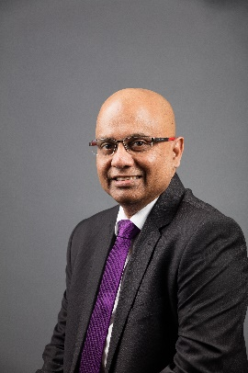
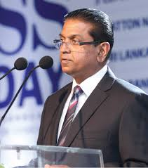
Hussain Sadiq
Founder President of SLRA
Murali Prakash
Vice President of SLRA
Sidath Kodikara
President of SLRA

